Brexit and the British Bill of Rights
Workshop and roundtable at Edinburgh Law School
Thursday 27 October, 10am – 5 pm (Raeburn Room, Old College, EH8 9YL)

Generously supported by the Thomas Paine Initiative

Organisers:
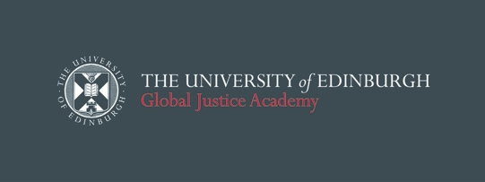

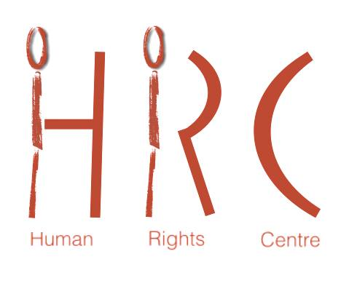

Contact: tobias.lock@ed.ac.uk
Programme

Chatham House Rules

A BBR and Implications of Multi-Level Governance (10.00-12.00)

1. The context: the implications of Brexit for human rights in the UK – Tobias Lock

2. Implications of the two sets of Article 50 litigation in England/Wales and in Northern Ireland concerning parliamentary sovereignty and constitutional law in Northern Ireland (including individual rights) for any future changes to the HRA or withdrawal from the ECHR –Christopher McCrudden

3. 'Response: ‘the current political context: Brexit, Parliament and Devolution’ – Stephen Tierney (tbc)

12.00-13.00: Buffet lunch

A BBR: Substantive questions: 13.00-15.00

4. A British Bill of Rights as a reduction in rights? –
- Interpretation of human rights: consequences of a removal of the obligation to ‘take into account’ Strasbourg case law – Alan Greene
- Reduction in the protection against extradition – Dimitrios Kagiaros
- Restriction of the extraterritorial application of UK human rights law – Fiona de Londras

5. A British Bill of Rights as an opportunity: better protection of procedural and administrative rights not adequately covered by the HRA –David Edward

15:00-15:30 Coffee

15.30 – 16:30 The BBR and the ECHR system

6. 'Brighton Five Years On' – Ed Bates (tbc)
7. UK human rights reform and its implications on the Convention system – Kanstantsin Dzehtsiarou

16.30-17.15
8. Update from the Joint Committee on Human Rights – Murray Hunt
followed by a roundtable discussion with representatives from human rights bodies on their policy on human rights reform

17.15 Drinks reception

Speaker information:
Dr Ed Bates, Senior Lecturer in Law, University of Leicester
Professor Christine Bell, Professor of Constitutional Law, Assistant Principal (Global Justice), Director of the Global Justice Academy, University of Edinburgh
Dr Kanstantsin Dzehtsiarou, Senior Lecturer in Law, University of Liverpool
Professor Sir David Edward QC, former judge at the Court of Justice of the EU and member of the Bill of Rights Commission
Dr Alan Greene, Lecturer in Law, University of Durham
Dr Dimitrios Kagiaros, Teaching Fellow in Public Law and Human Rights Law, University of Edinburgh
Dr Tobias Lock, Senior Lecturer in EU Law, co-director of the Europa Institute, University of Edinburgh
Professor Fiona de Londras, Professor of Global Legal Studies, University of Birmingham
Professor Christopher McCrudden, Professor of Human Rights and Equality Law, Queen's University Belfast
Murray Hunt, Legal Adviser to the Joint Committee on Human Rights
Representatives from the human rights bodies

